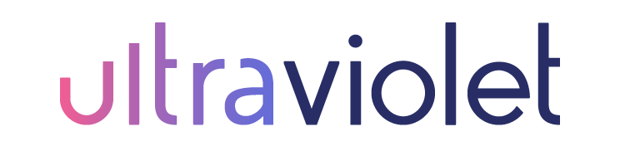

Social Media Engagement Intern
Summer/Fall 2023

Ultraviolet Agency offers a flexible schedule and creative atmosphere for digital marketing and communications professionals. The Social Media Engagement Intern works under the direction and management of Sarah Conley, Director of Social Media. As a member of the uv team, this internship will assist the agency in community management and engagement for media for uv’s clients. The goal is to work with fellow uv team members to create sustainable relationships on social media that drive success to client goals.

Each member of the agency team must be a self-starter, a doer, and have a passion for personal growth with the ability to…

- Listen
- Learn
- Teach

We believe in…
- Owning the work
- Leaning on each other
- Celebrating wins
- Learning from mistakes
- Work includes but is not limited to:

Work includes, but is not limited to, the following:

- Responding to follower comments, inquiries, and reviews as needed.
- Daily social PR for client accounts including messaging, liking, sharing, and commenting on accounts to grow followers and engagement.
- Gathering client data and social insights for reporting.
- Researching and implementing new social media strategies, tools, and tactics to fulfill campaign goals associated with client social media growth and engagement.

Interns will be trained on the following digital tools: HubSpot, Asana, Canva, Google drive and Analytics, SEM Rush, TailWind, ChatGPT, and various social media platforms and Ai tools.

Interested in an internship with Ultraviolet, please Apply here!
Have questions, contact jen@ultravioletagency.com.

